

2026/2027 Tender Register
[includes details on all Tender, Formal RFQ and EOI processes undertaken for the Fin Yr 2026/27]

This Tender Register is available for inspection by members of the public and other interested parties in person at the Shire Administration Building, cnr Kalgan and Newman Drives, Newman, WA, 6753.
The Register is also available to view online via the Shire’s website: www.eastpilbara.wa.gov.au.

Table of Contents
Contents
RFT 01-2026/27 – Reticulation Upgrade – Capricorn Oval Precinct 3
RFT 02-2026/27 – Entry and Exit Signage Project 5
RFT 03-2026/27 – Social Impact Assessment – Newman Youth & Community Hub Project 7
RFT 04-2026/27 – Interactive Virtual Walkthrough 9
RFT 05-2026/27 – East Newman Greening Initiative 11
RFT 06-2026/27 – Playground Softfall 13
RFT 07-2026/27 – Playground Equipment Renewal and Refurbishment 15
RFT 08-2026/27 – Goanna Oval Lighting Upgrade Project 17
RFT 09-2026/27 – Supply & Delivery Chemicals (Periodic Supply) 19
RFT 10-2026/27 – Road Repairs TC Zelia – South & East 21
RFT 11-2026/27 – Road Repairs TC Zelia – North 23
RFT 12-2026/27 – Airport Masterplan 25
RFQ 01-2026/27 – 27
RFQ 02-2026/27 – 29
RFQ 03-2026/27 – 31
RFQ 04-2026/27 – 33
RFQ 05-2026/27 – 35
VP 01-2026/27 – Supply/Deliver One (1) 6 x 4 Service Truck (Flat Bed) 37
VP 02-2026/27 – Supply/Deliver Two (2) Tractors 39
VP 03-2026/27 – Supply/Deliver Two (2) Skid Steer Loaders 41
VP 04-2026/27 – Supply/Deliver Three (3) Prime Movers 43
VP 05-2026/27 – 45
VP 06-2026/27 – 47
VP 07-2026/27 – 49
EOI 01-2026/27 – Leasing Opportunity – Ex Rifle Club 51
EOI 02-2026/27 – Leasing Opportunity – Airport Storage Shed 53
EOI 03-2026/27 – Establishment of Prequalified Supplier Panel – Property Demolition (Preliminary Selection) 55
EOI 04-2026/27 – Leasing Opportunity – Ex BJJ Clubhouse 57
EOI 05-2026/27 – Leasing Opportunity – Ex Sporting Shooters Club 59
EOI 06-2026/27 – Leasing Opportunity – Office 1, Newman House 61
EOI 07-2026/27 – Leasing Opportunity – 64
EOI 08-2026/27 – Leasing Opportunity – 67

TENDER DETAILS

RFT 01-2026/27 – Reticulation Upgrade – Capricorn Oval Precinct
Particulars of the Decision to Invite Tenders: |  | Procurement Policy – Threshold for RFT Process
Brief Description of the Goods and/or Services Required:
The Shire of East Pilbara invites tenders from suitably qualified and experienced contractors for the design and construction of irrigation and reticulation upgrades at Capricorn, Kangaroo, Emu and Goanna Ovals in Newman. The Works include investigation and assessment of existing infrastructure, hydraulic modelling and detailed design, together with the renewal, replacement and integration of irrigation, reticulation, pump station, storage, electrical and control infrastructure. The successful Contractor will also be responsible for testing, commissioning, operator training, reinstatement and handover of the completed systems.
ADVERTISEMENT & ELECTRONIC TENDERBOX OPENING DETAILS
Advertisement Date: | Wednesday, 12th August 2026
Advertisement Platform: | Shire Website Public Noticeboards Tenderlink  Shire Facebook Page West Australian Newspaper
Advertised Closing Details: | 10:00am, Tuesday, 8th September 2026
Updated Closing Details
Tenderbox Opening Date and Time:
Opened in the Presence of:

TENDERS RECEIVED FROM
No. | Company Name | Address | Contact Name
1
2
3
4

NOTICE
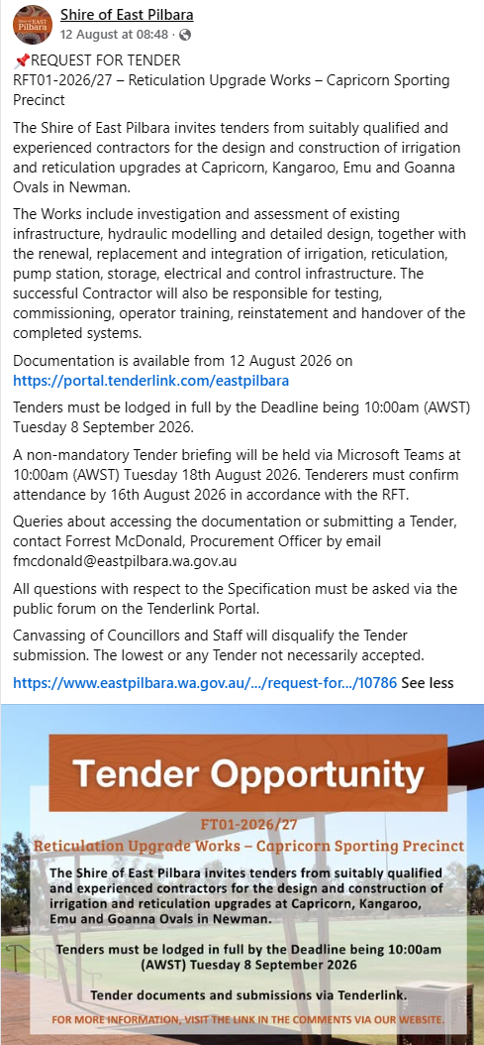
TENDER OUTCOME
Date of Award Decision
Award Decision By
Award Method
Name of Successful Tenderer
Contract Value
Term of Contract
Other Comments

TENDER DETAILS

RFT 02-2026/27 – Entry and Exit Signage Project
Particulars of the Decision to Invite Tenders: |  | Procurement Policy – Threshold for RFT Process
Brief Description of the Goods and/or Services Required:
The Shire of East Pilbara invites Tenders from Contractors who are suitably qualified and experienced to design, fabricate and install six (6) entry/exit signs throughout the Shire’s local government area boundaries. It proposed that the signs will be delivered in two sizes i.e. large (3.2m wide x 4m high) and small (2m wide x 2.6m high).
ADVERTISEMENT & ELECTRONIC TENDERBOX OPENING DETAILS
Advertisement Date: | Wednesday, 22nd July 2026
Advertisement Platform: | Shire Website Public Noticeboards Tenderlink  Shire Facebook Page West Australian Newspaper
Advertised Closing Details: | 10am, Thursday, 6th August 2026
Updated Closing Details | 10am, Monday, 10th August 2026
Tenderbox Opening Date and Time: | 10:05am, Monday, 10th August 2026
Opened in the Presence of: | Dawn Ronchi, Coordinator Procurement  Joshua Brown, Manager Governance, Risk & Procurement

TENDERS RECEIVED FROM
No. | Company Name | Address | Contact Name
1 | Augen Design | 30 Hamilton Street  BASSENDEAN WA 6054 | Sylvain Haass,  08 6278 2338
2 | Byblos Constructions P/L | P.O Box 292  PARABURDOO WA 6985 | Karen Spedding  Ph : 08 9189 5637
3 | Danthonia Designs | 4188 Gwdir Highway ELSMORE INVERELL NSW 2360 | Leandra Warner  Ph : 02 6708 4385
4

NOTICE
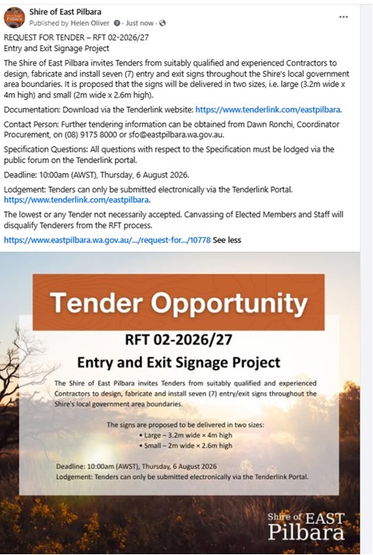
TENDER OUTCOME
Date of Award Decision
Award Decision By
Award Method
Name of Successful Tenderer
Contract Value
Term of Contract
Other Comments

TENDER DETAILS

RFT 03-2026/27 – Social Impact Assessment – Newman Youth & Community Hub Project
Particulars of the Decision to Invite Tenders: |  | Procurement Policy – Threshold for RFT Process
Brief Description of the Goods and/or Services Required:
The Shire of East Pilbara invites Tenders from suitably qualified and experienced consultants to undertake a Social Impact Assessment and develop a Social Impact Evaluation Plan for the Newman Youth and Community Hub Project. The successful Consultant will be required to deliver a multi-year assessment and evaluation framework that aligns with industry best practice and satisfies the requirements of the Shire, its external funding partners, and the community.
ADVERTISEMENT & ELECTRONIC TENDERBOX OPENING DETAILS
Advertisement Date: | Tuesday, 28th July 2026
Advertisement Platform: | Shire Website Public Noticeboards Tenderlink  Shire Facebook Page West Australian Newspaper
Advertised Closing Details: | 10am, Tuesday, 25th August 2026
Tenderbox Opening Date and Time: | 1:00pm, Tuesday, 25th August 2026
Opened in the Presence of: | Dawn Ronchi, Coordinator Procurement  Forrest McDonald, Governance & Procurement Officer
TENDERS RECEIVED FROM
No. | Company Name | Address | Contact Name
1 | Abt Associates | PO Box 1874, Milton QLD 4064 | Sanjoti Parekh - Ph : 0731144600
2 | BDO Services Pty Ltd | GPO Box 457, BRISBANE QLD 400 | Bids Team - Ph : 07 3237 5999
3 | Centre for Performance and Insight. Pty Ltd | 5 Grafton Road, Bayswater WA 6053 | Andrew Watt - Ph : 0432260500
4 | CGM Communications | PO Box 112, WEST PERTH WA 6005 | Anthony Fisk - Ph : 04 6898 9250
5 | Fiona Reeves |  | Fiona Reeves - Ph : 0424995614
6 | First Nations Economics Ltd | 13 triton Street, Lennox Head, NSW 2478 | Madii Page -Ph : 0432 358 27
7 | Janali & Co | 139 Alma Road, NORTH PERTH | Sarah Janali - Ph : 0417936418
8 | K D Solutions |  | Kane Sparks - Ph : 0488164010
9 | Kimberley Flanagan Consulting | PO Box 979, Berwick VIC 3806 | Kimberley Flanagan - Ph : 0428991469
10 | Malu Matriarchs Collective Pty Ltd | 10 Beaconsfield Street, Hyde Park SA 5061 | Amy Gildea - Ph : 0428618437
11 | RFF Pty Ltd | 22 Carnarvon Street, Broome WA 6725 | Owen Hightower - Ph : 0477 056 937
12 | Social Sphere |  | Jillian Ash - Ph : 0404974909
13 | Thao Ashford Planning Consultant | 10 Dale Street, CAPALABA QLD 415 | Thao Ashford - Ph : 0419840390
14 | University of Western Australia | 35 Stirling Hwy, Crawley WA 6009 | Margaret Martin - Ph : 08 6488 3527
15 | Urban & Regional Planning Solutions | 27 Halifax Street, ADELAIDE SA 5000 | Josephine Laird - Ph : 0883337999
16 | Yamagigu Consulting Pty Ltd |  | Sam Kalamafoni - Ph : .
17
NOTICE
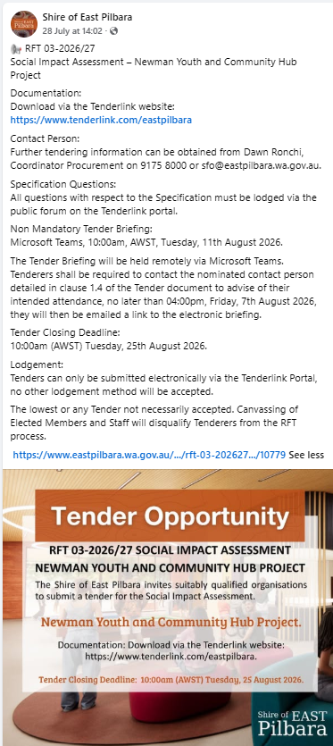
TENDER OUTCOME
Date of Award Decision
Award Decision By
Award Method
Name of Successful Tenderer
Contract Value
Term of Contract
Other Comments

TENDER DETAILS

RFT 04-2026/27 – Interactive Virtual Walkthrough
Particulars of the Decision to Invite Tenders: |  | Procurement Policy – Threshold for RFT Process
Brief Description of the Goods and/or Services Required:
The Shire of East Pilbara (Shire or SoEP) invites Tenders from Consultants who are suitably qualified and experienced to undertake the planning, concept development, storyboarding, digital modelling, 3D integration, and delivery of an Interactive Virtual Walkthrough. The final product must be professional, accurate, visually consistent, and suitable for public presentations, community engagement, and online use.
ADVERTISEMENT & ELECTRONIC TENDERBOX OPENING DETAILS
Advertisement Date: | Monday, 3rd August 2026
Advertisement Platform: | Shire Website Public Noticeboards Tenderlink  Shire Facebook Page West Australian Newspaper
Advertised Closing Details: | 10am, Wednesday, 19th August 2026
Tenderbox Opening Date and Time: | 1:25pm, Wednesday, 19th August 2026
Opened in the Presence of: | Dawn Ronchi, Coordinator Procurement  Haylee Heaslip, Governance Officer

TENDERS RECEIVED FROM
No. | Company Name | Address | Contact Name
1 | Arterial Design Pty Ltd | Suite 2 45 Watkins Street  FITZROY NORTH VIC 3068 | Jan Nowell  Ph : 03 94 82 61 66
2 | Convergen | Level 5, Tech Central, Lot 14 ADELAIDE SA 5000 | Anton Andreacchio  Ph : 0870738437
3 | Digital Syndicate Studios Pty Ltd T/A Spatial Media | 3 Bonython Street  WINDSOR QLD 4030 | James Noble  Ph : 1300772842
4 | Primitive AI | 46 Winderie Road  GOLDEN BAY WA 6174 | Polina Stolyarova  Ph : 0431482887
5 | WSP Australia Pty Limited | GPO Box 5394  SYDNEY NSW 2000 | WA tenders  Ph : 02 9272 5631
6

NOTICE
Social media Posts https://www.facebook.com/share/p/19HbFNvQtS/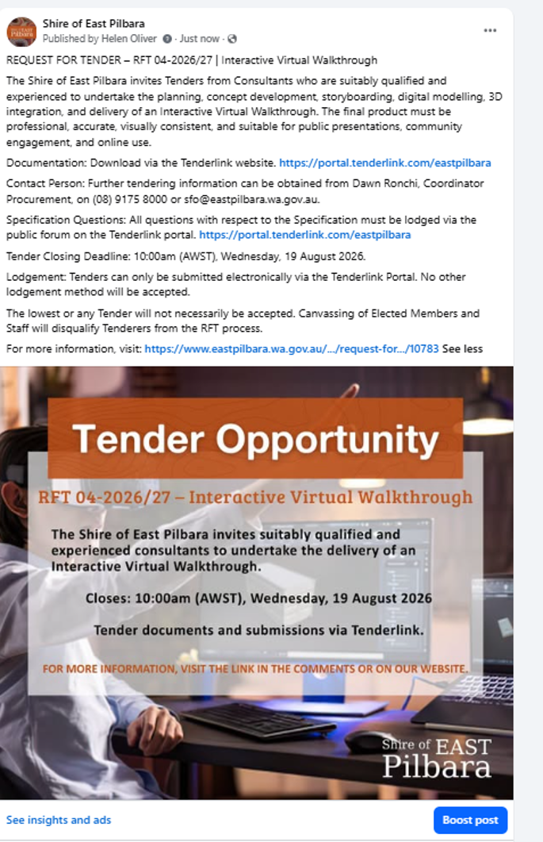
TENDER OUTCOME
Date of Award Decision
Award Decision By
Award Method
Name of Successful Tenderer
Contract Value
Term of Contract

TENDER DETAILS

RFT 05-2026/27 – East Newman Greening Initiative
Particulars of the Decision to Invite Tenders: |  | Procurement Policy – Threshold for RFT Process
Brief Description of the Goods and/or Services Required:
The Shire of East Pilbara invites Tenders from suitably qualified and experienced contractors to design, supply, construct, test, commission and hand over recycled-water infrastructure for the East Newman Corridor Greener Initiative.
The Works comprise recycled-water reticulation and irrigation infrastructure, together with a minimum 100 kL recycled-water storage tank, pump station and associated compound works.
The two Separable Portions may be awarded separately or together.
ADVERTISEMENT & ELECTRONIC TENDERBOX OPENING DETAILS
Advertisement Date: | Saturday, 29th August 2026
Advertisement Platform: | Shire Website Public Noticeboards Tenderlink  Shire Facebook Page West Australian Newspaper
Advertised Closing Details: | 10am, Friday, 18th September 2026
Tenderbox Opening Date and Time:
Opened in the Presence of: | Forrest McDonald, Governance & Procurement Officer  2nd Officer

TENDERS RECEIVED FROM
No. | Company Name | Address | Contact Name
1
2
3
4

NOTICE
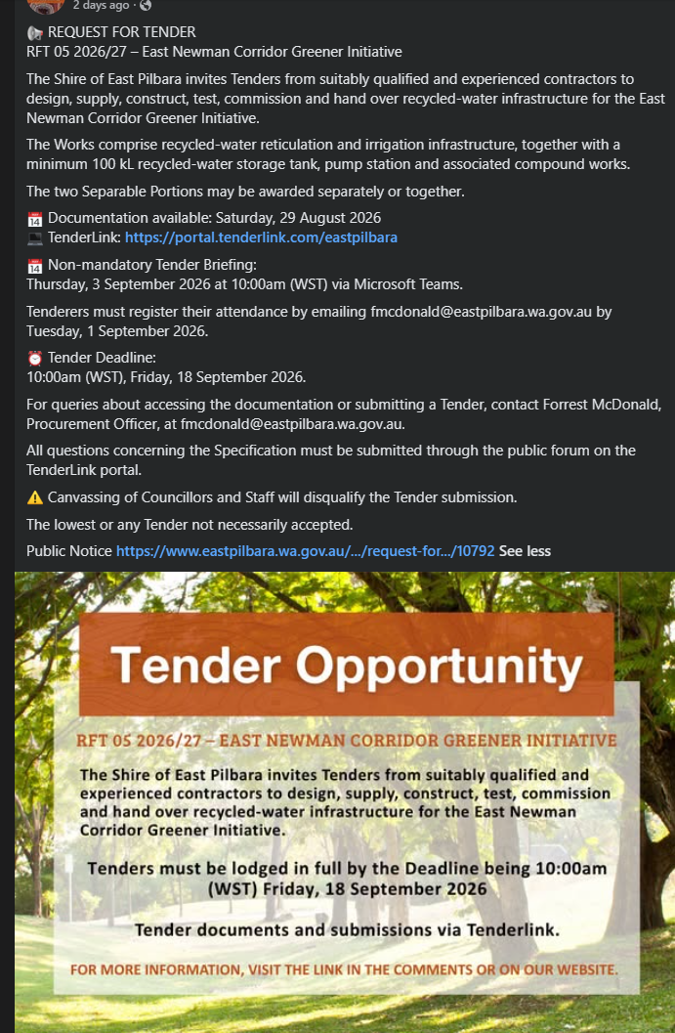
TENDER OUTCOME
Date of Award Decision
Award Decision By
Award Method
Name of Successful Tenderer
Contract Value
Term of Contract
Other Comments

TENDER DETAILS

RFT 06-2026/27 – Playground Softfall
Particulars of the Decision to Invite Tenders: |  | Procurement Policy – Threshold for RFT Process
Brief Description of the Goods and/or Services Required:

ADVERTISEMENT & ELECTRONIC TENDERBOX OPENING DETAILS
Advertisement Date:
Advertisement Platform: | Shire Website Public Noticeboards Tenderlink  Shire Facebook Page West Australian Newspaper
Advertised Closing Details:
Updated Closing Details
Tenderbox Opening Date and Time:
Opened in the Presence of: | Forrest McDonald, Governance & Procurement Officer  2nd Officer

TENDERS RECEIVED FROM
No. | Company Name | Address | Contact Name
1
2
3
4

NOTICE
TENDER OUTCOME
Date of Award Decision
Award Decision By
Award Method
Name of Successful Tenderer
Contract Value
Term of Contract
Other Comments

TENDER DETAILS

RFT 07-2026/27 – Playground Equipment Renewal and Refurbishment
Particulars of the Decision to Invite Tenders: |  | Procurement Policy – Threshold for RFT Process
Brief Description of the Goods and/or Services Required:
The Shire of East Pilbara invites Tenders from suitably qualified, experienced and competent Contractors to undertake the playground equipment removal, replacement, installation, maintenance, repair, painting, protective coating, associated civil works, reinstatement, testing, certification and handover requirements at the nominated playground locations across Newman, Western Australia.
ADVERTISEMENT & ELECTRONIC TENDERBOX OPENING DETAILS
Advertisement Date: | Saturday, 29th August 2026
Advertisement Platform: | Shire Website Public Noticeboards Tenderlink  Shire Facebook Page West Australian Newspaper
Advertised Closing Details: | 10am, Tuesday, 15th September 26
Updated Closing Details
Tenderbox Opening Date and Time:
Opened in the Presence of: | Dawn Ronchi, Coordinator Procurement  2nd Officer

TENDERS RECEIVED FROM
No. | Company Name | Address | Contact Name
1
2
3
4

NOTICE
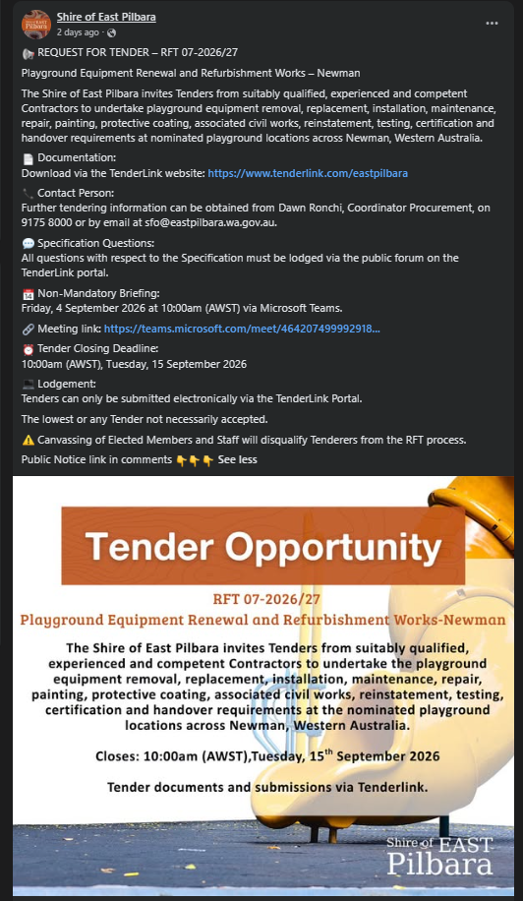
TENDER OUTCOME
Date of Award Decision
Award Decision By
Award Method
Name of Successful Tenderer
Contract Value
Term of Contract
Other Comments

TENDER DETAILS

RFT 08-2026/27 – Goanna Oval Lighting Upgrade Project
Particulars of the Decision to Invite Tenders: |  | Procurement Policy – Threshold for RFT Process
Brief Description of the Goods and/or Services Required:
The Shire of East Pilbara invites Tenders from suitably qualified, licensed, and experienced Contractors for the design, supply, installation, testing, commissioning and handover of new LED sports lighting systems for Goanna Oval, Newman, Western Australia. The project involves the replacement and upgrade of the existing sports lighting infrastructure with a modern, energy-efficient LED lighting system designed to enhance lighting performance, improve operational reliability, and support the ongoing use of the facility for community and sporting activities. The new lighting installation shall be fully integrated with the Shire's existing Musco lighting control system to ensure seamless operation, monitoring, and control.
ADVERTISEMENT & ELECTRONIC TENDERBOX OPENING DETAILS
Advertisement Date: | Monday, 17th August 2026
Advertisement Platform: | Shire Website Public Noticeboards Tenderlink  Shire Facebook Page West Australian Newspaper
Advertised Closing Details: | 10am, Tuesday, 8th September 2026
Updated Closing Details: | n/a
Tenderbox Opening Date and Time: | Xxxx, Tuesday, 8th September 2026
Opened in the Presence of: | Dawn Ronchi, Coordinator Procurement  Jeremy House, Contract Compliance Investigator

TENDERS RECEIVED FROM
No. | Company Name | Address | Contact Name
1
2
3
4

NOTICE
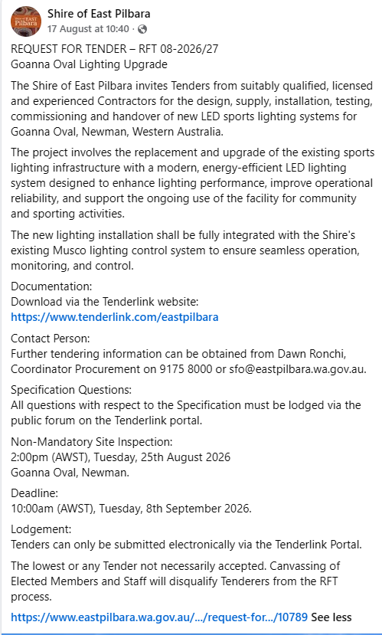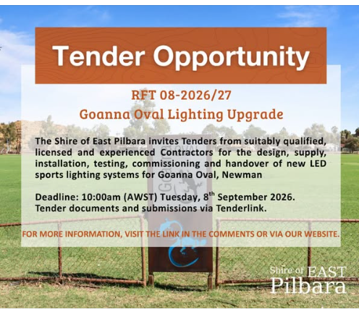
TENDER OUTCOME
Date of Award Decision
Award Decision By
Award Method
Name of Successful Tenderer
Contract Value
Term of Contract
Other Comments

TENDER DETAILS

RFT 09-2026/27 – Supply & Delivery Chemicals (Periodic Supply)
Particulars of the Decision to Invite Tenders: |  | Procurement Policy – Threshold for RFT Process
Brief Description of the Goods and/or Services Required:
The Principal invites Offers from suitably qualified and licensed Suppliers for the supply and delivery of water treatment chemicals and testing consumables.
ADVERTISEMENT & ELECTRONIC TENDERBOX OPENING DETAILS
Advertisement Date: | Monday, 31st August 2026
Advertisement Platform: | Shire Website Public Noticeboards Tenderlink  Shire Facebook Page West Australian Newspaper
Advertised Closing Details: | 10am, Tuesday, 22nd September 2026
Updated Closing Details:
Tenderbox Opening Date and Time:
Opened in the Presence of: | Forrest McDonald, Governance and Procurement Officer  2nd Officer

TENDERS RECEIVED FROM
No. | Company Name | Address | Contact Name
1
2
3
4

NOTICE
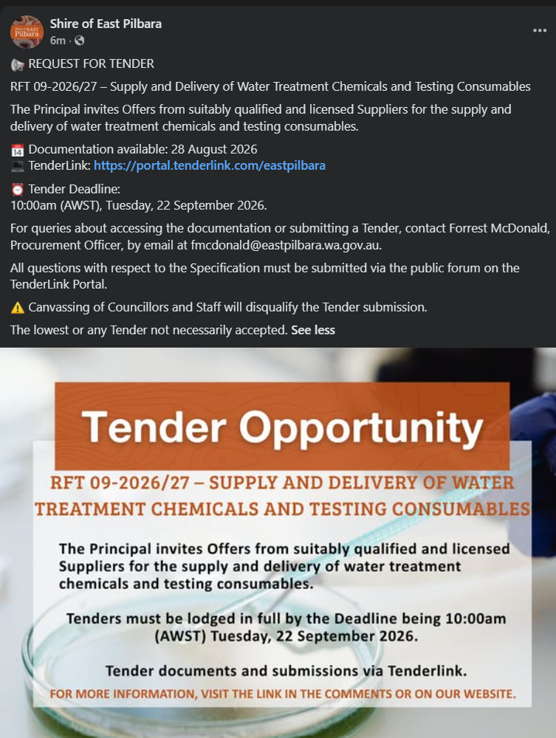
TENDER OUTCOME
Date of Award Decision
Award Decision By
Award Method
Name of Successful Tenderer
Contract Value
Term of Contract
Other Comments

TENDER DETAILS

RFT 10-2026/27 – Road Repairs TC Zelia – South & East
Particulars of the Decision to Invite Tenders: |  | Procurement Policy – Threshold for RFT Process
Brief Description of the Goods and/or Services Required:

ADVERTISEMENT & ELECTRONIC TENDERBOX OPENING DETAILS
Advertisement Date:
Advertisement Platform: | Shire Website Public Noticeboards Tenderlink  Shire Facebook Page West Australian Newspaper
Advertised Closing Details:
Updated Closing Details:
Tenderbox Opening Date and Time:
Opened in the Presence of: | Forrest McDonald, Governance & Procurement Officer  2nd Officer

TENDERS RECEIVED FROM
No. | Company Name | Address | Contact Name
1
2
3
4

NOTICE
TENDER OUTCOME
Date of Award Decision
Award Decision By
Award Method
Name of Successful Tenderer
Contract Value
Term of Contract
Other Comments

TENDER DETAILS

RFT 11-2026/27 – Road Repairs TC Zelia – North
Particulars of the Decision to Invite Tenders: |  | Procurement Policy – Threshold for RFT Process
Brief Description of the Goods and/or Services Required:
The Shire of East Pilbara invites Tenders from suitably qualified Contractors to provide road repair works of various roads within the Shire of East Pilbara, following damage caused by Tropical Cyclone Zelia in February 2026.
ADVERTISEMENT & ELECTRONIC TENDERBOX OPENING DETAILS
Advertisement Date: | Saturday, 15th August 2026
Advertisement Platform: | Shire Website Public Noticeboards Tenderlink  Shire Facebook Page West Australian Newspaper
Advertised Closing Details: | 10am, Friday, 11th September 2026
Updated Closing Details:
Tenderbox Opening Date and Time:
Opened in the Presence of: | Forrest McDonald, Governance & Procurement Officer  2nd Officer

TENDERS RECEIVED FROM
No. | Company Name | Address | Contact Name
1
2
3
4

NOTICE
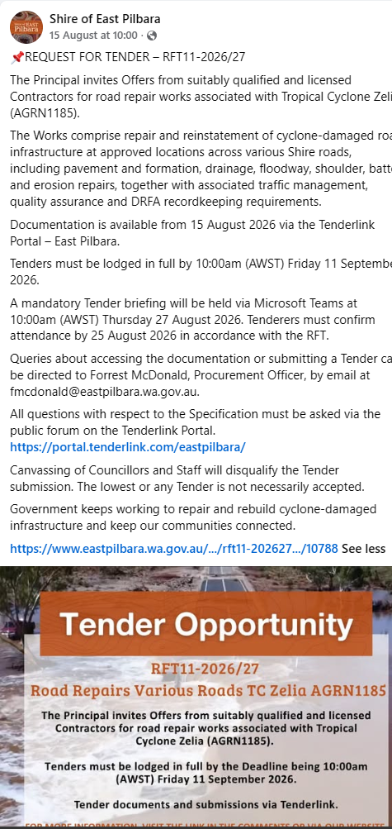
TENDER OUTCOME
Date of Award Decision
Award Decision By
Award Method
Name of Successful Tenderer
Contract Value
Term of Contract
Other Comments

TENDER DETAILS

RFT 12-2026/27 – Airport Masterplan
Particulars of the Decision to Invite Tenders: |  | Procurement Policy – Threshold for RFT Process
Brief Description of the Goods and/or Services Required:
The Shire of East Pilbara invites Tenders from suitably qualified and experienced consultants to prepare a comprehensive Airport Master Plan that will establish a long-term strategic vision for the development of Newman Airport over the next 20 years. The Airport Master Plan will assess existing infrastructure, operational capacity, land use, regulatory compliance, environmental considerations, and future aviation demand to identify opportunities for staged development and investment.
The Airport Master Plan will include a review of current airport facilities, airside and landside infrastructure, terminal operations, aviation support services, utilities, access and parking, commercial development opportunities, and future land requirements. It will also incorporate aviation demand forecasting, stakeholder consultation, concept planning, capital works prioritisation, implementation strategies, and cost estimates to support informed decision-making.
ADVERTISEMENT & ELECTRONIC TENDERBOX OPENING DETAILS
Advertisement Date: | Tuesday, 18th August 2026
Advertisement Platform: | Shire Website Public Noticeboards Tenderlink  Shire Facebook Page West Australian Newspaper
Advertised Closing Details: | 10am, Tuesday, 8th September 2026
Updated Closing Details:
Tenderbox Opening Date and Time:
Opened in the Presence of: | Dawn Ronchi, Coordinator Procurement  2nd Officer

TENDERS RECEIVED FROM
No. | Company Name | Address | Contact Name
1
2
3
4

NOTICE
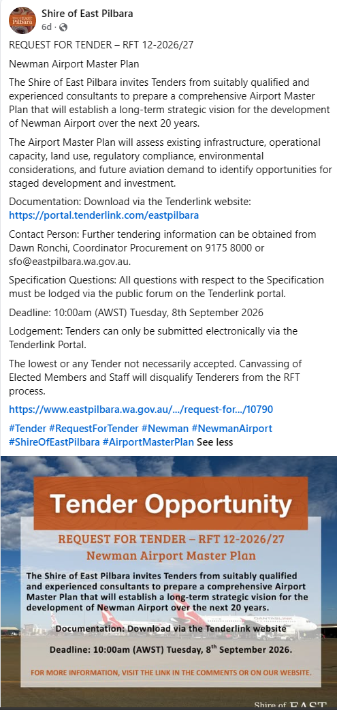

TENDER OUTCOME
Date of Award Decision
Award Decision By
Award Method
Name of Successful Tenderer
Contract Value
Term of Contract
Other Comments

FORMAL QUOTATION DETAILS

RFQ 01-2026/27 –
Particulars of the Decision to Invite Formal Quotations: |  | Procurement Policy – Threshold for Formal RFQ Process
Brief Description of the Goods and/or Services Required:

ADVERTISEMENT & ELECTRONIC TENDERBOX OPENING DETAILS
Advertisement Date:
Advertisement Platform: | Shire Website Public Noticeboards Tenderlink  Shire Facebook Page West Australian Newspaper
Advertised Closing Details:
Updated Closing Details:
Tenderbox Opening Date and Time:
Opened in the Presence of:

OFFERS RECEIVED FROM
No. | Company Name | Address | Contact Name
1
2
3
4

NOTICE

RFX OUTCOME
Date of Award Decision
Award Decision By
Award Method
Name of Successful Tenderer
Contract Value
Term of Contract
Other Comments

FORMAL QUOTATION DETAILS

RFQ 02-2026/27 –
Particulars of the Decision to Invite Formal Quotations: |  | Procurement Policy – Threshold for Formal RFQ Process
Brief Description of the Goods and/or Services Required:

ADVERTISEMENT & ELECTRONIC TENDERBOX OPENING DETAILS
Advertisement Date:
Advertisement Platform: | Shire Website Public Noticeboards Tenderlink  Shire Facebook Page West Australian Newspaper
Advertised Closing Details:
Updated Closing Details:
Tenderbox Opening Date and Time:
Opened in the Presence of:

OFFERS RECEIVED FROM
No. | Company Name | Address | Contact Name
1
2
3
4

NOTICE

RFX OUTCOME
Date of Award Decision
Award Decision By
Award Method
Name of Successful Tenderer
Contract Value
Term of Contract
Other Comments

FORMAL QUOTATION DETAILS

RFQ 03-2026/27 –
Particulars of the Decision to Invite Formal Quotations: |  | Procurement Policy – Threshold for Formal RFQ Process
Brief Description of the Goods and/or Services Required:

ADVERTISEMENT & ELECTRONIC TENDERBOX OPENING DETAILS
Advertisement Date:
Advertisement Platform: | Shire Website Public Noticeboards Tenderlink  Shire Facebook Page West Australian Newspaper
Advertised Closing Details:
Updated Closing Details:
Tenderbox Opening Date and Time:
Opened in the Presence of:

OFFERS RECEIVED FROM
No. | Company Name | Address | Contact Name
1
2
3
4

NOTICE

RFX OUTCOME
Date of Award Decision
Award Decision By
Award Method
Name of Successful Tenderer
Contract Value
Term of Contract
Other Comments

FORMAL QUOTATION DETAILS

RFQ 04-2026/27 –
Particulars of the Decision to Invite Formal Quotations: |  | Procurement Policy – Threshold for Formal RFQ Process
Brief Description of the Goods and/or Services Required:

ADVERTISEMENT & ELECTRONIC TENDERBOX OPENING DETAILS
Advertisement Date:
Advertisement Platform: | Shire Website Public Noticeboards Tenderlink  Shire Facebook Page West Australian Newspaper
Advertised Closing Details:
Updated Closing Details:
Tenderbox Opening Date and Time:
Opened in the Presence of:

OFFERS RECEIVED FROM
No. | Company Name | Address | Contact Name
1
2
3
4

NOTICE

OUTCOME
Date of Award Decision
Award Decision By
Award Method
Name of Successful Tenderer
Contract Value
Term of Contract
Other Comments

FORMAL QUOTATION DETAILS

RFQ 05-2026/27 –
Particulars of the Decision to Invite Formal Quotations: |  | Procurement Policy – Threshold for Formal RFQ Process
Brief Description of the Goods and/or Services Required:

ADVERTISEMENT & ELECTRONIC TENDERBOX OPENING DETAILS
Advertisement Date:
Advertisement Platform: | Shire Website Public Noticeboards Tenderlink  Shire Facebook Page West Australian Newspaper
Advertised Closing Details:
Updated Closing Details:
Tenderbox Opening Date and Time:
Opened in the Presence of:

OFFERS RECEIVED FROM
No. | Company Name | Address | Contact Name
1
2
3
4

NOTICE

OUTCOME
Date of Award Decision
Award Decision By
Award Method
Name of Successful Tenderer
Contract Value
Term of Contract
Other Comments

FORMAL QUOTATION DETAILS (Using WALGA Preferred Suppliers)

VP 01-2026/27 – Supply/Deliver One (1) 6 x 4 Service Truck (Flat Bed)
Particulars of the Decision to Invite Formal Quotations: | Procurement Policy – Threshold for Formal RFQ Process
Brief Description of the Goods and/or Services Required:
The Shire of East Pilbara invites Offers from equipment dealers, manufacturers or authorised distributors for the supply and delivery of one (1) new Flat Bed Truck 6x4 to be used as a fuel/service truck for the Infrastructure Services Road Maintenance crew.
RELEASE, CLOSING & ELECTRONIC TENDERBOX OPENING DETAILS
Invitees and Date(s) Invited
Invited via WALGA PSP No. | Fleet (PSP006) - Heavy Rigid Vehicles (PSP006-015)
Invited to Submit an Offer | - C J D Equipment Pty Ltd  - Daimler Trucks Geraldton  - Daimler Trucks Perth  - Major Motors Isuzu  - PENSKE AUSTRALIA PTY LTD  - The Trustee For Truck Unit Trust (WA Hino)  - Volvo Group Australia Pty Ltd
Release Date: | Thursday, 27th August 2026
Original Closing Details | 10am, Monday, 14th September 2026
Amended Closing Details
Tenderbox Opening Date and Time:
Opened in the Presence of: | Dawn Ronchi, Coordinator Procurement

OFFERS RECEIVED FROM
No. | Company Name | Address | Contact
1
2
3
4

OUTCOME
Date of Award Decision
Award Decision By
Award Method
Name of Successful Tenderer
Contract Value
Term of Contract
Other Comments

FORMAL QUOTATION DETAILS (Using WALGA Preferred Suppliers)

VP 02-2026/27 – Supply/Deliver Two (2) Tractors
Particulars of the Decision to Invite Formal Quotations: | Procurement Policy – Threshold for Formal RFQ Process
Brief Description of the Goods and/or Services Required:
The Shire of East Pilbara invites Offers from equipment dealers, manufacturers or authorised distributors for the supply and delivery of two (2) x new Tractors minimum 82kW to be used by the Infrastructure Services Parks & Gardens Teams for mowing & slashing oval facilities and maintaining grassed ovals.
RELEASE, CLOSING & ELECTRONIC TENDERBOX OPENING DETAILS
Invitees and Date(s) Invited
Invited via WALGA PSP No. | Fleet (PSP006-001 – Agriculture Plant)  Fleet (PSP0060-010 – Material Handling Equipment of  Fleet (PSP006-003) – Turf Plant
Invited to Submit an Offer | - Clark Equipment Sales  - John Deere Limited  - Kubota Australia  - Wattleup Tractors
Original Closing Details | 10am, Monday, 21st September 2026
Amended Closing Details
Tenderbox Opening Date and Time:
Opened in the Presence of:

OFFERS RECEIVED FROM
No. | Company Name | Address | Contact Name
1
2
3
4

OUTCOME
Date of Award Decision
Award Decision By
Award Method
Name of Successful Tenderer
Contract Value
Term of Contract
Other Comments

FORMAL QUOTATION DETAILS (Using WALGA Preferred Suppliers)

VP 03-2026/27 – Supply/Deliver Two (2) Skid Steer Loaders
Particulars of the Decision to Invite Formal Quotations: | Procurement Policy – Threshold for Formal RFQ Process
Brief Description of the Goods and/or Services Required:

RELEASE, CLOSING & ELECTRONIC TENDERBOX OPENING DETAILS
Invitees and Date(s) Invited
Invited via WALGA PSP No.
Invitee 1
Invitee 2
Invitee 3
Original Closing Details | 10am,
Amended Closing Details
Tenderbox Opening Date and Time:
Opened in the Presence of:

OFFERS RECEIVED FROM
No. | Company Name | Address | Contact Name
1
2
3
4

OUTCOME
Date of Award Decision
Award Decision By
Award Method
Name of Successful Tenderer
Contract Value
Term of Contract
Other Comments

FORMAL QUOTATION DETAILS (Using WALGA Preferred Suppliers)

VP 04-2026/27 – Supply/Deliver Three (3) Prime Movers
Particulars of the Decision to Invite Formal Quotations: | Procurement Policy – Threshold for Formal RFQ Process
Brief Description of the Goods and/or Services Required:
The Principal requires the supply and delivery of three (3) new, white, 6x4 conventional bonneted (long-nose) prime movers for road maintenance operations. The vehicles will undertake sustained operation across the Shire's unsealed and off-road operating environment.
RELEASE, CLOSING & ELECTRONIC TENDERBOX OPENING DETAILS
Invitees and Date(s) Invited
Invited via WALGA PSP No. | Fleet (PSP006-020 – Prime Mover)
Invited to Submit an Offer | - CJD Equipment  - Daimler Trucks Geraldton  - Daimler Trucks Perth  - Penske Australia  - Volvo Group Australia
Original Closing Details | 10am, Tuesday, 8th September 2026
Amended Closing Details
Tenderbox Opening Date and Time:
Opened in the Presence of:

OFFERS RECEIVED FROM
No. | Company Name | Address | Contact Name
1
2
3
4

OUTCOME
Date of Award Decision
Award Decision By
Award Method
Name of Successful Tenderer
Contract Value
Term of Contract
Other Comments

FORMAL QUOTATION DETAILS (Using WALGA Preferred Suppliers)

VP 05-2026/27 –
Particulars of the Decision to Invite Formal Quotations: | Procurement Policy – Threshold for Formal RFQ Process
Brief Description of the Goods and/or Services Required:

RELEASE, CLOSING & ELECTRONIC TENDERBOX OPENING DETAILS
Invitees and Date(s) Invited
Invited via WALGA PSP No.
Invitee 1
Invitee 2
Invitee 3
Original Closing Details | 10am,
Amended Closing Details
Tenderbox Opening Date and Time:
Opened in the Presence of:

OFFERS RECEIVED FROM
No. | Company Name | Address | Contact Name
1
2
3
4

OUTCOME
Date of Award Decision
Award Decision By
Award Method
Name of Successful Tenderer
Contract Value
Term of Contract
Other Comments

FORMAL QUOTATION DETAILS (Using WALGA Preferred Suppliers)

VP 06-2026/27 –
Particulars of the Decision to Invite Formal Quotations: | Procurement Policy – Threshold for Formal RFQ Process
Brief Description of the Goods and/or Services Required:

RELEASE, CLOSING & ELECTRONIC TENDERBOX OPENING DETAILS
Invitees and Date(s) Invited
Invited via WALGA PSP No.
Invitee 1
Invitee 2
Invitee 3
Original Closing Details | 10am,
Amended Closing Details
Tenderbox Opening Date and Time:
Opened in the Presence of:

OFFERS RECEIVED FROM
No. | Company Name | Address | Contact Name
1
2
3
4

OUTCOME
Date of Award Decision
Award Decision By
Award Method
Name of Successful Tenderer
Contract Value
Term of Contract
Other Comments

FORMAL QUOTATION DETAILS (Using WALGA Preferred Suppliers)

VP 07-2026/27 –
Particulars of the Decision to Invite Formal Quotations: | Procurement Policy – Threshold for Formal RFQ Process
Brief Description of the Goods and/or Services Required:

RELEASE, CLOSING & ELECTRONIC TENDERBOX OPENING DETAILS
Invitees and Date(s) Invited
Invited via WALGA PSP No.
Invitee 1
Invitee 2
Invitee 3
Original Closing Details | 10am,
Amended Closing Details
Tenderbox Opening Date and Time:
Opened in the Presence of:

OFFERS RECEIVED FROM
No. | Company Name | Address | Contact Name
1
2
3
4

OUTCOME
Date of Award Decision
Award Decision By
Award Method
Name of Successful Tenderer
Contract Value
Term of Contract
Other Comments

EXPRESSION OF INTEREST (EOI) DETAILS

EOI 01-2026/27 – Leasing Opportunity – Ex Rifle Club
EOI Type (i.e. Procurement or Disposal) | Disposal of Property
Particulars of the Decision to Call for Expressions of Interest:
Local Government Act 1995 - Section 3.58 – Disposal of Property - A local government can dispose of property (including by sale, lease, or other disposition) only in accordance with this section. Disposal can occur by:
a) Public auction;
b) Public tender; or
c) Directly to certain bodies/individuals (with specific exemptions).
Used the EOI process because it demonstrates openness, transparency, and market testing, while meeting the Disposal Requirements.
Brief Description:
The Shire of East Pilbara invites Expressions of Interest from interested parties for development and activation of Reserve 44387, being Land ID 3081949, Plan P218627 Lot 139, in accordance with the Expression of Interest documentation.
The land is currently vested for Recreation purposes and presents an opportunity for proponents to explore compatible recreational, tourism, community, commercial, sporting, or other appropriate development opportunities, subject to relevant approvals.
The site comprises approximately 118.93 hectares of undeveloped land and was previously utilised as one of Western Australia’s largest public rifle ranges.
ADVERTISEMENT & ELECTRONIC TENDERBOX OPENING DETAILS
Advertisement Date: | Wednesday, 15th July 2026
Advertisement Platform: | Shire Website Public Noticeboards Tenderlink  Shire Facebook Page West Australian Newspaper
Advertised Closing Details: | 10:00 am, Monday, 17th August 2026
Tenderbox Opening Date and Time: | 8:00 am, Tuesday, 18th August 2026
Opened in the Presence of: | Dawn Ronchi, Coordinator Procurement

EXPRESSIONS OF INTEREST RECEIVED FROM
No. | Company Name | Address | Contact Name
1 | Newman Branch Sporting Shooters Association of Australia (WA) Inc | PO Box 336, Newman, WA, 6753 | Kane Mauriohooho
2

NOTICE
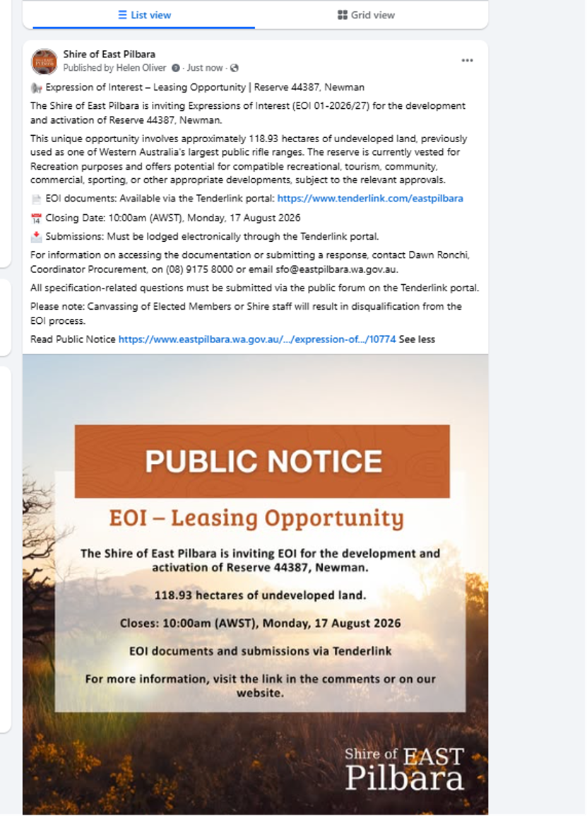
EXPRESSION OF INTEREST OUTCOME
Date of Award Decision
Award Decision By
Award Method
Name of Successful Respondent
Value
Term (Lease/Contract)
Other Comments

EXPRESSION OF INTEREST (EOI) DETAILS

EOI 02-2026/27 – Leasing Opportunity – Airport Storage Shed
EOI Type (i.e. Procurement or Disposal) | Disposal of Property
Particulars of the Decision to Call for Expressions of Interest:
Local Government Act 1995 - Section 3.58 – Disposal of Property - A local government can dispose of property (including by sale, lease, or other disposition) only in accordance with this section. Disposal can occur by:
a) Public auction;
b) Public tender; or
c) Directly to certain bodies/individuals (with specific exemptions).
Used the EOI process because it demonstrates openness, transparency, and market testing, while meeting the Disposal Requirements.
Brief Description:

ADVERTISEMENT & ELECTRONIC TENDERBOX OPENING DETAILS
Advertisement Date:
Advertisement Platform: | Shire Website Public Noticeboards Tenderlink  Shire Facebook Page West Australian Newspaper
Advertised Closing Details:
Tenderbox Opening Date and Time:
Opened in the Presence of:

EXPRESSIONS OF INTEREST RECEIVED FROM
No. | Company Name | Address | Contact Name
1
2
3
4

NOTICE

EXPRESSION OF INTEREST OUTCOME
Date of Award Decision
Award Decision By
Award Method
Name of Successful Respondent
Value
Term (Lease/Contract)
Other Comments

EXPRESSION OF INTEREST (EOI) DETAILS

EOI 03-2026/27 – Establishment of Prequalified Supplier Panel – Property Demolition (Preliminary Selection)
EOI Type (i.e. Procurement or Disposal) | Procurement
Particulars of the Decision to Call for Expressions of Interest:
To gauge interest in Contractors being part of a Prequalified Supplier Panel.
Brief Description:
This EOI forms Stage 1 of a two-stage procurement process. Its purpose is to identify contractors with the experience, licences, safety systems, resources and capacity necessary to participate in a subsequent restricted Request for Tender. Following Stage 2, the Shire intends to establish a panel of pre-approved contractors that may be engaged to undertake residential demolition works in Newman on an as-required basis. Submission of an EOI does not appoint a Respondent to the proposed Panel or guarantee an invitation to Stage 2 or any future work.
ADVERTISEMENT & ELECTRONIC TENDERBOX OPENING DETAILS
Advertisement Date: | Wed, 29th July 2026
Advertisement Platform: | Shire Website Public Noticeboards Tenderlink  Shire Facebook Page West Australian Newspaper
Advertised Closing Details: | 10am, Friday, 14th August 2026
Tenderbox Opening Date and Time:
Opened in the Presence of: | Forrest McDonald, Governance & Procurement Officer
EXPRESSIONS OF INTEREST RECEIVED FROM
No. | Company Name | Address | Contact Name
1 | ARCO Environmental Solutions | 10 Halley Road, Balcatta, WA | Kelly Oloughlin  Ph : 0401594553/1800943640
2 | Ahrens Group | PO Box 2, SHEAOAK LOG SA 5371 | Cameron Hall  Ph : 08 8521 0000
3 | AKT Demolition Pty Ltd | 16 Midas Road, MALAGA WA 6090 | Dan Ince  Ph : 0468493669
4 | Brajkovich Demolition & Salvage (WA) Pty Ltd | 1686 Great Northern Highway, Upper Swan WA 6069 | Carmen Tyson  Ph : 0418945443/ 0892278222
5 | Delta Group | 1/32 Ledgar Road, Balcatta WA 6163 | Andrew Farrell  Ph : 08 9240 6200
6 | Demex Pty Ltd | PO Box 375, Ormeau QLD 4208 | Christine Allen  Ph : 1300 634 777
7 | McMahon Services Australia Pty Ltd | 26 Duncan Road, Dry Creek SA 5094 | Tenders Department  Ph : 08 8203 3100
8 | Merit Consulting Group | P.O Box 3165, MALAGA DC WA 6945 | Stephen King  Ph : (08) 9277 3360
9 | North West Asbestos Solutions | PO Box 6335, BROOME WA 6725 | Dean Howlett  Ph : 0410 263 464
10 | Thuroona Services | 34 Cocos Drive, BIBRA LAKE WA 6163 | Contact : Kevin White  Ph : 0437624836
11 | Veolia Environmental Services (Australia) Pty Ltd | 4/65 Pirrama Road, Pyrmont NSW 2009 | Veolia Tendering  Ph : (02) 8572 0400
12
NOTICE
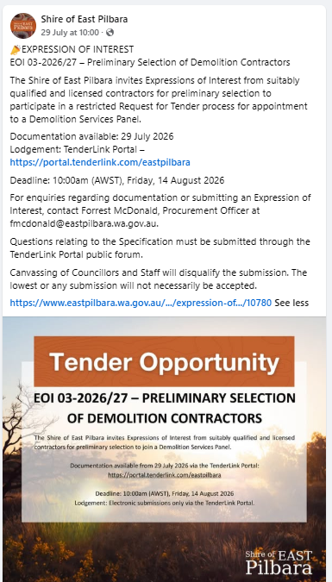
EXPRESSION OF INTEREST OUTCOME
Date of Short-listing Decision
Short-listing Decision Made by | Chief Executive Officer
Name of Short-listed Respondents
Restricted Tender Process – RFT | RFT xx-2026/27
Other Comments

EXPRESSION OF INTEREST (EOI) DETAILS

EOI 04-2026/27 – Leasing Opportunity – Ex BJJ Clubhouse
EOI Type (i.e. Procurement or Disposal) | Disposal of Property
Particulars of the Decision to Call for Expressions of Interest:
Local Government Act 1995 - Section 3.58 – Disposal of Property - A local government can dispose of property (including by sale, lease, or other disposition) only in accordance with this section. Disposal can occur by:
a) Public auction;
b) Public tender; or
c) Directly to certain bodies/individuals (with specific exemptions).
Used the EOI process because it demonstrates openness, transparency, and market testing, while meeting the Disposal Requirements.
Brief Description:
The Shire of East Pilbara invites Expressions of Interest from suitable organisations for the occupation, activation and where appropriate, further development of the existing Brazilian Jiu Jitsu clubhouse at North Newman Reserve.
The proposed lease area is approximately 720 m² and is intended for sporting club and community use, or another compatible use that delivers demonstrable benefit to the Newman community.
ADVERTISEMENT & ELECTRONIC TENDERBOX OPENING DETAILS
Advertisement Date: | Friday, 31st July 2026
Advertisement Platform: | Shire Website Public Noticeboards Tenderlink  Shire Facebook Page West Australian Newspaper
Advertised Closing Details: | 10am, Thursday, 27th August 2026
Tenderbox Opening Date and Time: | 10am, Thursday, 27th August 2026
Opened in the Presence of: | Forrest McDonald, Governance & Procurement Officer

EXPRESSIONS OF INTEREST RECEIVED FROM
No. | Company Name | Address | Contact Name
1 | No Offers Received
2
3
4

NOTICE
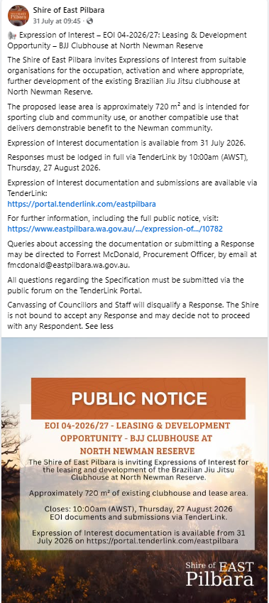
EXPRESSION OF INTEREST OUTCOME
Date of Award Decision
Award Decision By
Award Method
Name of Successful Respondent
Value
Term (Lease/Contract)

EXPRESSION OF INTEREST (EOI) DETAILS

EOI 05-2026/27 – Leasing Opportunity – Ex Sporting Shooters Club
EOI Type (i.e. Procurement or Disposal) | Disposal of Property
Particulars of the Decision to Call for Expressions of Interest:
Local Government Act 1995 - Section 3.58 – Disposal of Property - A local government can dispose of property (including by sale, lease, or other disposition) only in accordance with this section. Disposal can occur by:
a) Public auction;
b) Public tender; or
c) Directly to certain bodies/individuals (with specific exemptions).
Used the EOI process because it demonstrates openness, transparency, and market testing, while meeting the Disposal Requirements
Brief Description:
The Shire of East Pilbara invites Expressions of Interest from interested parties to utilise the land, Newman Lot 2347, Windell Location 139 on Land Administration Plan 18627. Crown Land Title No 3082/645 and being a portion of Reserve no 44387 vested in the Shire of East Pilbara.
The land is currently vested for Recreation purposes and presents an opportunity for proponents to explore compatible recreational, community, sporting, or other appropriate development opportunities, subject to relevant approvals.
The lease area is an area of 14.95 ha of land on the south-east edge of Newman, at the end of Gun Club Road. It currently houses the buildings and facilities that make up the Clay Shooters Club.
Note: This is a separate area of land, than that offered for Lease under EOI 01-2026/27.
ADVERTISEMENT & ELECTRONIC TENDERBOX OPENING DETAILS
Advertisement Date: | Monday, 10th August 2026
Advertisement Platform: | Shire Website Public Noticeboards Tenderlink  Shire Facebook Page West Australian Newspaper
Advertised Closing Details: | 10am, Monday, 24th August 2026
Tenderbox Opening Date and Time: | 3:25pm, Monday, 24th August 2026
Opened in the Presence of: | Dawn Ronchi, Coordinator Procurement

EXPRESSIONS OF INTEREST RECEIVED FROM
No. | Company Name | Address | Contact Name
1 | Newman Clay Target Club Inc | PO Box 397, NEWMAN WA 6753 | Matthew Anick Ph : 0447 002 515
2

NOTICE
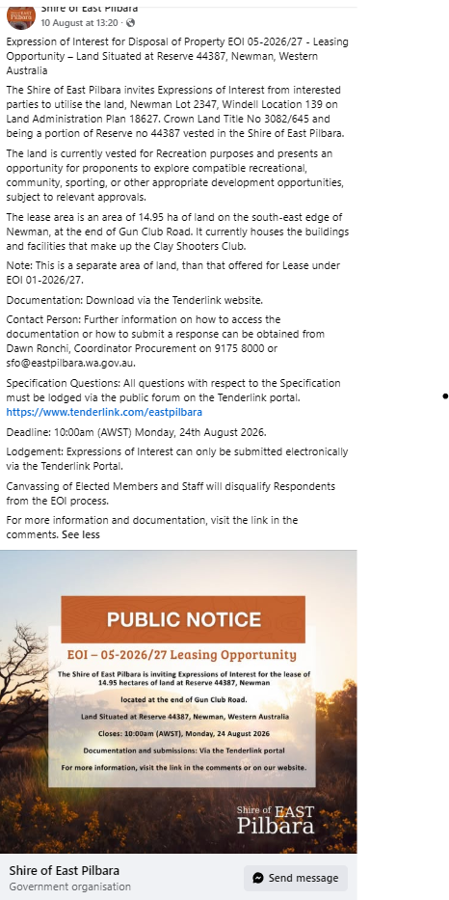
EXPRESSION OF INTEREST OUTCOME
Date of Award Decision
Award Decision By
Award Method
Name of Successful Respondent
Value
Term (Lease/Contract)

EXPRESSION OF INTEREST (EOI) DETAILS

EOI 06-2026/27 – Leasing Opportunity – Office 1, Newman House
EOI Type (i.e. Procurement or Disposal) | Disposal of Property
Particulars of the Decision to Call for Expressions of Interest:
Local Government Act 1995 - Section 3.58 – Disposal of Property - A local government can dispose of property (including by sale, lease, or other disposition) only in accordance with this section. Disposal can occur by:
a) Public auction;
b) Public tender; or
c) Directly to certain bodies/individuals (with specific exemptions).
Used the EOI process because it demonstrates openness, transparency, and market testing, while meeting the Disposal Requirements.
Brief Description:

ADVERTISEMENT & ELECTRONIC TENDERBOX OPENING DETAILS
Advertisement Date:
Advertisement Platform: | Shire Website Public Noticeboards Tenderlink  Shire Facebook Page West Australian Newspaper
Advertised Closing Details:
Tenderbox Opening Date and Time:
Opened in the Presence of:

EXPRESSIONS OF INTEREST RECEIVED FROM
No. | Company Name | Address | Contact Name
1
2
3
4

NOTICE

EXPRESSION OF INTEREST OUTCOME
Date of Award Decision
Award Decision By
Award Method
Name of Successful Respondent
Value
Term (Lease/Contract)
Other Comments

EXPRESSION OF INTEREST (EOI) DETAILS

EOI 07-2026/27 – Leasing Opportunity –
EOI Type (i.e. Procurement or Disposal) | Disposal of Property
Particulars of the Decision to Call for Expressions of Interest:
Local Government Act 1995 - Section 3.58 – Disposal of Property - A local government can dispose of property (including by sale, lease, or other disposition) only in accordance with this section. Disposal can occur by:
a) Public auction;
b) Public tender; or
c) Directly to certain bodies/individuals (with specific exemptions).
Used the EOI process because it demonstrates openness, transparency, and market testing, while meeting the Disposal Requirements.
Brief Description:

ADVERTISEMENT & ELECTRONIC TENDERBOX OPENING DETAILS
Advertisement Date:
Advertisement Platform: | Shire Website Public Noticeboards Tenderlink  Shire Facebook Page West Australian Newspaper
Advertised Closing Details:
Tenderbox Opening Date and Time:
Opened in the Presence of:

EXPRESSIONS OF INTEREST RECEIVED FROM
No. | Company Name | Address | Contact Name
1
2
3
4

NOTICE

EXPRESSION OF INTEREST OUTCOME
Date of Award Decision
Award Decision By
Award Method
Name of Successful Respondent
Value
Term (Lease/Contract)
Other Comments

EXPRESSION OF INTEREST (EOI) DETAILS

EOI 08-2026/27 – Leasing Opportunity –
EOI Type (i.e. Procurement or Disposal) | Disposal of Property
Particulars of the Decision to Call for Expressions of Interest:
Local Government Act 1995 - Section 3.58 – Disposal of Property - A local government can dispose of property (including by sale, lease, or other disposition) only in accordance with this section. Disposal can occur by:
a) Public auction;
b) Public tender; or
c) Directly to certain bodies/individuals (with specific exemptions).
Used the EOI process because it demonstrates openness, transparency, and market testing, while meeting the Disposal Requirements.
Brief Description:

ADVERTISEMENT & ELECTRONIC TENDERBOX OPENING DETAILS
Advertisement Date:
Advertisement Platform: | Shire Website Public Noticeboards Tenderlink  Shire Facebook Page West Australian Newspaper
Advertised Closing Details:
Tenderbox Opening Date and Time:
Opened in the Presence of:

EXPRESSIONS OF INTEREST RECEIVED FROM
No. | Company Name | Address | Contact Name
1
2
3
4

NOTICE
EXPRESSION OF INTEREST OUTCOME
Date of Award Decision
Award Decision By
Award Method
Name of Successful Respondent
Value
Term (Lease/Contract)
Other Comments

